x



Flight Information Display System

Graphical User Interface Manual

(February 2008)

Digital Images International Pty Ltd
Unit 8
5 Parsons Street
Rozelle NSW 2039
Australia
Tel: +61- 2 9555 1855
Fax: +61- 2 9555 8802
Email: support@dii.com.au
Web: www.dii.com.au
Table of Contents

System Operation 3
System Log On 3
Window Geography 4
FIDS Home Window 5
File Menu 6
Messages Menu 6
View Menu 7
Time Tables Menu 7
Configure Menu 8
User Authorisation Window 9
Table Editor 11
Details Window Editor 12
FIDS Home Window Editor 13
Bay Allocator Window Editor 13
System Settings 14
Bay to Gate Mapping 14
Checkin to Lateral Map 15
Messages 16
Keypad Buttons 17
Miscellaneous Menu 18
Help Menu 18
Speed Buttons 19
Arrivals Window 20
Arrivals Speed Buttons 21
Arrivals Details Window 22
Departures Window 23
Departures Speed Buttons 24
Departures Details Window 25
Checkins Window 26
Checkins Speed Buttons 27
IATA Code Window 27
IATA Code Speed Buttons 28
IATA Code Details Window 28
Timetable Editor Window 29
Timetable Editor Speed Buttons 29
Timetable Editor Details Window 30
Crawling Lines Window 32
Crawling Lines Speed Buttons 33
Reports Window 33
Screen Selector Window 34
Bay Allocator Window 35
Bay Allocator Speed Buttons 37
Translations Window 38

System Operation
When the FIDS GUI is started, it will first load the configuration and establish a connection with the FIDS Host. Once that has been successfully completed, the current FIDS Database will be downloaded, and the System Logon window will be displayed.

If at any time, the GUI is not able to communicate with an active host then the GUI will be “greyed out" and cannot be operated. When communication with a host is restored then the GUI will automatically revert to normal colours and operation.

System Log On
At system start-up on the FIDS Workstation, the Operator will be presented with the following window:
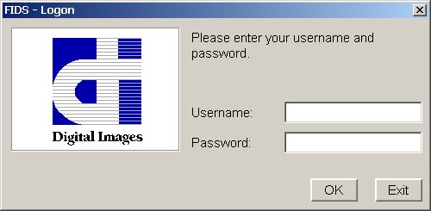
Using this window the operator should enter his/her username and password, and then click on “OK” to log on the GUI, clicking on “Exit" will shut down the operator console application.

The System Manager will be responsible for the creation and management of operator usernames and passwords.

After signing on, the GUI will finish loading and display the main window and (if logging on as a System Manager) a Screen Selector Window will be hidden off the right of the screen.

Window Geography
Apart from special purpose dialogs, most windows within the application use a consistent geography. This means that no-matter which window the Operator is using the look-and-feel of the window will be the same.
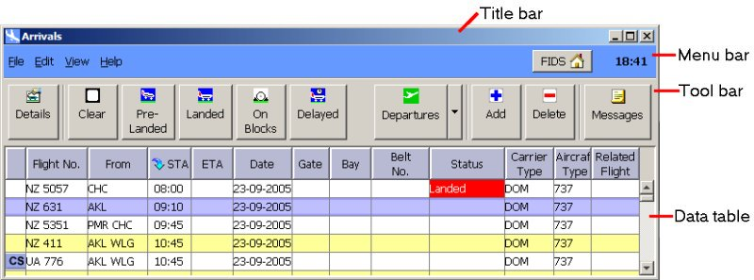
The Title bar describes the type of information or data that is displayed within the window.

The Menu bar provides a number of menu items that relate to the data on display. The Tool bar contains a number of buttons, which change based upon the type of data on display. Speed buttons are provided to allow the operator to carry out special actions in a timely manner.

In many windows, the Data table presents actual data from the database. Depending on the level of operator, the data in the table may be read-only. For example, only System Managers are able to edit IATA Codes.

Double clicking on a record in a table will bring up the details window for that record to allow editing of its details if you have the appropriate operator level for the data being used. The details window can also be accessed via the edit menu.

FIDS Home Window
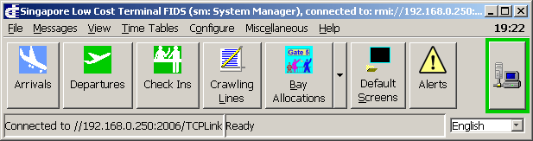

Once the Operator has logged on, this window is placed at the top left of the screen. It provides access to the primary features of the system.

The title bar displays the user name of the operator logged into the system, their operator level and the name of the host computer they are connected to.

The main window provides a number of menus. Note that some items may be disabled or not visible due to the access level of the signed on user.

To the right of the toolbar is a “Status button” which indicates the overall state of the FIDS. When logged in as a System Manager, this button may be pressed to invoke the FIDS Status window. Generally, a green border indicates that the system is functioning correctly. Any other colour indicates that at least one critical component of the system is not running as expected.

At the bottom of this window is a status bar. The left hand segment of the Status Bar shows the state of communications with the host and the right hand segment is the status or activity of the connection. Right clicking over the right hand segment gives access to a pop up menu allowing the display of the activity log or the error log.

To the right of the status bar is a language selector that allows the operator to select one of the languages from those that the system has been configured for.

File Menu

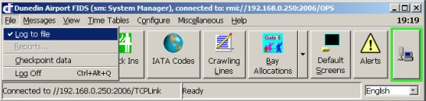

The “File" menu provides the Operator with the following options:
- Log to file: This menu item, when ticked indicates that all system messages that normally appear in the Status Bar (see below) are logged to a disk file.
- Reports: This menu item is used to access reports that the system can generate.
- Checkpoint data: This menu item causes a snapshot of the current data to be written to disk.
- Log Off: As it suggests, this menu item allows the currently logged on Operator to log off. This leaves the workstation ready for another user to log on. To exit the program click on exit in the log on screen.

Messages Menu
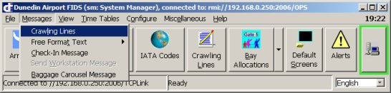
The “Messages" menu provides an alternative way to invoke the Crawling Lines window, Free Formate Text, Check-In Message, Baggage Carousel Message and other message functions within the FIDS.

View Menu
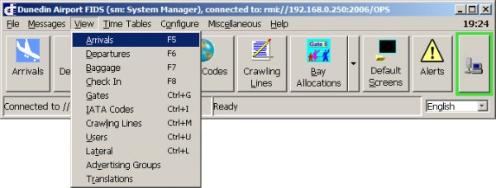
The “View" menu provides a method by which the user can invoke windows to display the different types of data that are managed by the system. For many of the menu items this is simply an alternative to the speed buttons such as Arrivals Window, Departures Window, Checkins Window, IATA Code Window, Crawling Lines Window, Translations Window and so on.

The Users menu item invokes a window that allows the System Manager to edit and maintain user account database.

Time Tables Menu

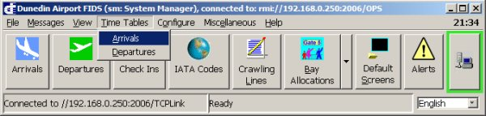

The Time Tables menu allows the operator to bring up an editing window to make changes to the time table from which the system draws its flight information.

Configure Menu

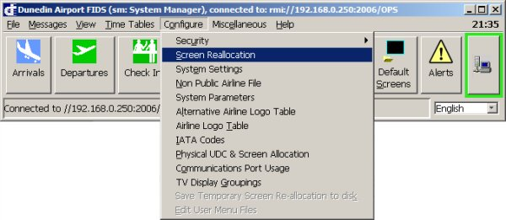

The Configure menu provides access to many system configuration settings. These settings should only be edited if there is a full understanding of how the settings affect the system.

- Security: Allows the choice between the "User Authorisation Window" and the "Change Password" window where the user is given the ability to manipulate their password.
- Screen Reallocation: Invokes a window that may be used to reconfigure screen allocations.
- System Settings: Invokes a window in which a number of system settings may be edited.
- Non Public Airline file: Invokes an editor for a file which is used for airlines (such as cargo operators) so that flight data can be shown on staff displays only.
- System Parameters: Invokes an editor in which a number of system wide parameters can be edited. Note that this is only available to system managers.
- Alternative Airline Logo Table: This menu item is used when there are flight numbers that require an alternative logo. Alternative logos can be given to a specific airline within a certain range of flight numbers.
- Airline Logo Table: Invokes a window in which the system airline logo table can be edited.
- IATA Codes: This menu item is an alternative to using the speed button.
- Physical UDC & Screen Allocation: This menu item is used when adding additional hardware to the system.
- Communication Port Usage: This menu item is used when adding additional hardware to the system. Note that editing this file requires a complete system restart.
- TV Display Groupings: This menu item is used to edit or create display groups. A display group is a number of frames that is displayed on a single display. The different frames can be displayed for periods of time or when certain conditions are met. Note that editing this file requires a complete system restart.

User Authorisation Window

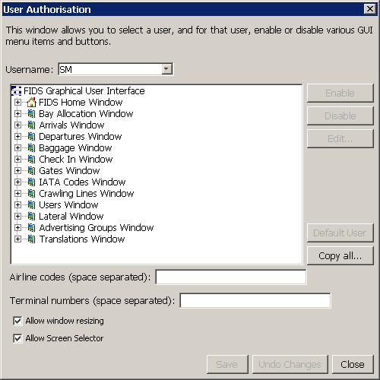

This window may be invoked from the Configure→Security menu when logged in as a System Manager.

It allows the System Manager to specify, on a per user basis, the level of access to the various features of the FIDS GUI.

When invoked, by default the window will display the permissions of the “Default User” if one has been defined. If none has been defined, then simply select a user from the drop down, and then click on “Default User”.

By default, all users are given the same access as the default user, unless their access level overrides this.

Where an item is not available to a user due to his access level, the item will be displayed with a symbol.

Most items can be disabled or enabled simply, by using the Enable and Disable buttons.

Some items, such as Data Tables or Details Windows may be edited using a specialised editor. When such an editor is available, clicking on Edit will invoke the editor.

If you need to copy the entire configuration for a given user to another user, use the “Copy all...” button.
The Airline codes text entry field allows the specification, for a given user, of one or more specific airline codes that are valid for that user. For example, entering “QF” would prevent the user from seeing any flights that have flight numbers that don’t start with “QF”.

The Terminal Number text entry field allows the specification, for a given user, of one or more specific terminal numbers that are valid for that user. For example, entering “T4” would prevent the user from seeing any flights that are not allocated to the “T4” terminal.

The Allow window resizing checkbox, when checked will allow the user to change the size of various windows within the FIDS GUI. In most cases this would be un-checked except for a system manager.

The Allow Screen Selector checkbox, when checked, will allow a System Manager level user to use the Screen Selector to display the contents of any UDC's configured into the system.

When one or more changes are made to the configuration, the “Save” button will become enabled, allowing you to save the changes. When this is done, the configuration is actually sent to the FIDS Host computer, and from there is it sent to all connected workstations. When a workstation receives it, the GUI will be reconfigured immediately. This allows the System Manager to make immediate changes to a users functionality from anywhere in the airport.

Note that changes to the user’s access level via the Users table view will require a user to log out and log back in.

Table Editor

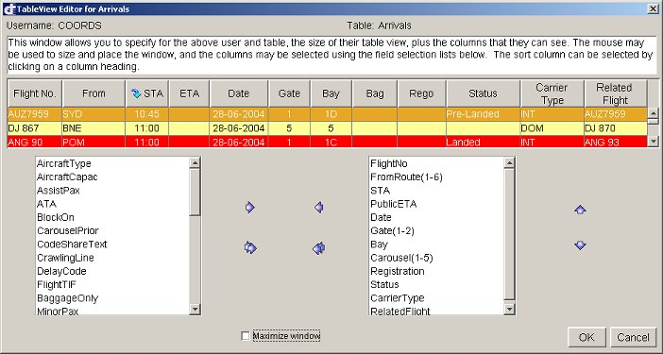

The main purpose of this window is to specify what fields are viewed in a given table, such as the Arrivals or Departures table. The DII FIDS database contains a large number of fields in each table not necessarily for public view but for data-logging purposes. This window allows the user to show what they need to see, or what they are able to see, within the limitations of their screen resolution.

The top centre of the screen shows which tables view is currently being edited - in this case the Arrivals table.

The list boxes are the main feature of the screen. The left box lists the every field that can be viewed on the Arrivals screen. The right box lists the fields that are currently active and visible on the Arrivals screen.
Fields can be added to the active list by selecting the required field in the left box and clicking the right arrow button, and can be removed by selecting the unwanted field on the right box and clicking the left arrow button. All fields can be added or removed to the active list using the double right arrow or double left arrow respectively.
To change the order of the fields in the right (active) list, select the required field and click the up or down arrow on the right side to move it to the right order of preference.

The table in the middle of the screen shows a sample of the Arrivals screen by the contents of the right list box.

It is also possible to specify that the window will default to a maximised state using the provided checkbox.

Details Window Editor

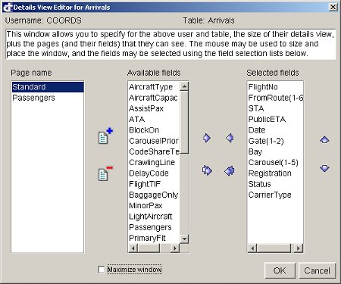

This window is invoked when the Edit button is clicked for a Details Window item in the User Authorisation window.

Using this window, the system manager may specify the size of the details window, what pages of fields to display, and which fields are displayed. The left window is the Page selector. Within the details window, the pages are separated by tabs. More pages may be introduced by clicking the new page icon:

The right window is the Selected fields that are inside that page. So in this instance we can see that the Standard page has STA, PublicETA and Date in the window. If the Passengers page was selected, the right side box (Selected Fields box) would have an entirely different set of information inside it.

To place information within the Selected Fields box select the required field in the Available fields box then click the Single Right Arrow button and it will be placed within the Selected Fields Box.

To change the order of the fields in the Selected Fields Box, select the required field and click the up or down arrow on the right side to move it to the right order of preference.

It is also possible to specify that the window will default to a maximised state using the provided checkbox.

FIDS Home Window Editor

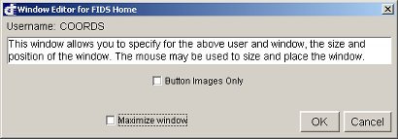

This window is invoked when the Edit button is clicked for the FIDS Home Window item in the User Authorisation window.

Using this window, the system manager may specify the size of the FIDS Home Window and the default state of the Button Images Only menu item in the Configure menu.

It is also possible to specify that the window will default to a maximised state using the provided checkbox.

Bay Allocator Window Editor

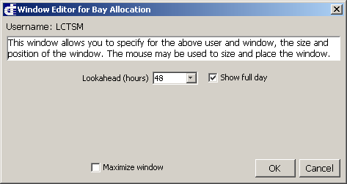

This window is invoked when the Edit button is clicked for the Bay Allocator Window item in the User Authorisation window.

Using this window, the system manager may specify the size of the Bay Allocator Window and the default state of the Show Full Day menu item in the Bay menu.

The default lookahead period can also be set here.

It is also possible to specify that the window will default to a maximised state.

System Settings

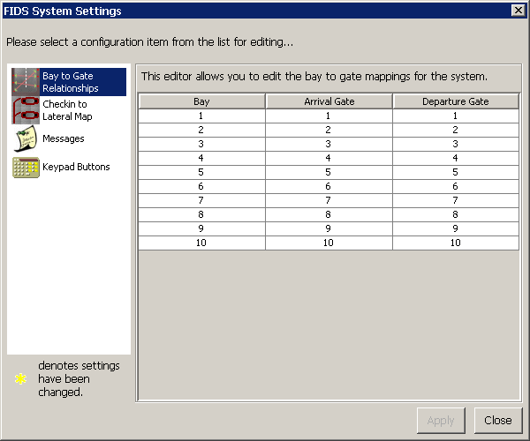

This window is where the system manager may edit a number of system settings such as the mapping of parking bays to arrival and departure gates, mapping of checkin belts to lateral belts, and the management of standard messages for allocation to screens.

Bay to Gate Mapping

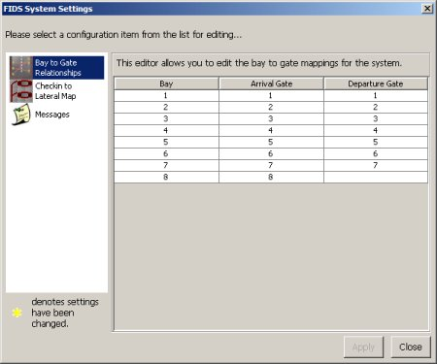

For each flight type (Arrivals or Departures), it is possible to specify a gate number for each bay in the system.

When one flights is allocated to a bay on the Gantt chart, the system will lookup the mapped gate and assign the flight to that gate. Likewise, if the flight is dragged to a new bay and its gate will also change to the correctly mapped gate.

It is also possible to leave the gate value blank for a bay if there is no specific gate that maps to a bay.

Checkin to Lateral Map

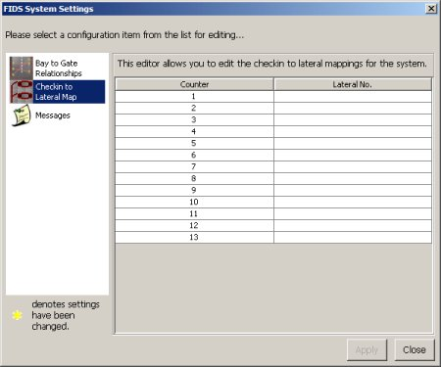

This editor allows the system manager to edit the mapping of checkin counters to specific laterals (where a lateral is a belt taking baggage from the checkin counter to air-side).

This feature allows flights allocated to a checkin counter to be automatically displayed on a given lateral screen air-side.

Messages

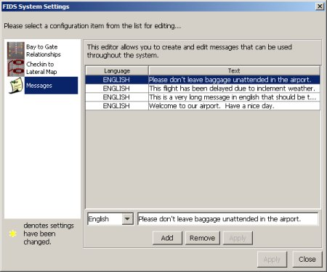

This editor allows the system manager to enter into the system a number of messages that can then be used to add to flights, checkin counters, baggage belts, etc.

Within this window, standard messages can be added and removed in different languages. To add a message, click the Add button, select the language you wish to write it in, and then click Apply. To remove a standard message, select the message on the table view, and then click on the Remove button underneath.

When so configured, the system will allow messages to be entered in several languages.

Keypad Buttons
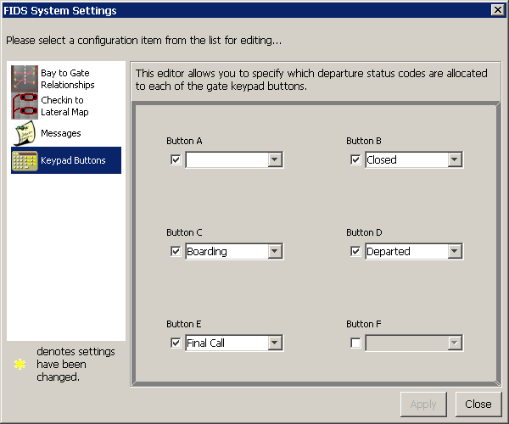
This editor allows the system manager to specify which departures status codes are allocated to each of the Gate keypad buttons.

Miscellaneous Menu
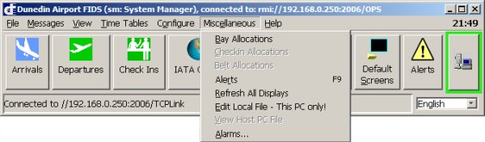
As the name suggests, this menu provides the operator with a number of miscellaneous functions:
- Bay Allocations: Invokes the Bay Allocator window.
- Alerts: invokes the Alerts window.
- Refresh All Displays allows a System Manager to force all UDC/VDG displays to be refreshed.
- Edit Local File - This PC Only! This menu item allows the System Manager to edit a file that is local to the PC. Note that this menu item will only be visible on systems configured to support it.
- Test Sound System allows a System Manager to test a connected sound system.
- Alarms…: This menu item allows an operator to enable/disable a system wide alarm.

Help Menu

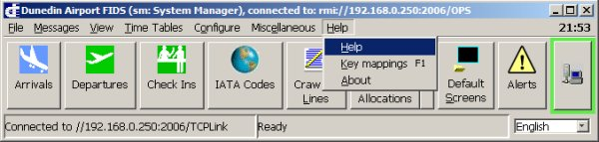

The “Help" menu provides access to this document online, and to an “About box" window. Using the help will start the computers default browser. The browser controls can be used for navigation and printing.

For keyboard mappings to the various buttons on the window use the Key mappings menu item.

Speed Buttons
The FIDS Home Window contains a number of “Speed Buttons”. These may be used to quickly navigate to a given window, eliminating the need to traverse a menu.

Invokes a window that will allow the Operator to view, and edit flight arrival records in the system database.

Invokes a window that will allow the Operator to view, and edit flight departure records in the system database.

Invokes a window that will allow the Operator to view, and assign flights to check in counters.

Invokes a window that may be used to maintain the list of destination codes.

Invokes a window that may be used to manipulate crawling lines on screens at the airport.

Instructs all screens in the airport to display their default screens.

Invokes the Bay Allocator window.

Invokes the Alerts window.

Allows a System Manager to invoke the System Status Window.

Arrivals Window
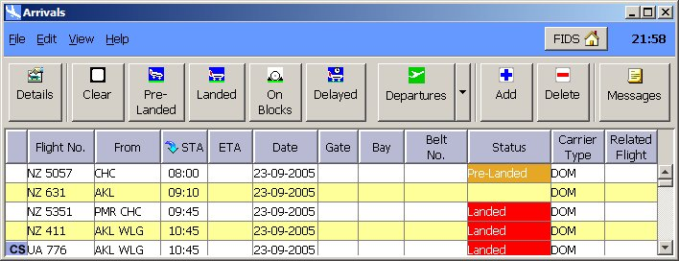
This window is a primary window for use by regular Operators of the FIDS. In this window, the Operator will be able to see an up-to-date picture of the current flights that are scheduled to arrive at the airport.

Each line in the table of data represents a single record in the database. These records are generated from the arrival timetable or from airline feeds. One off or charter flights that are not in the timetable can be added to the database using this screen. If the new flight is to be a regular event then it should be entered in the timetable accessed from the “Time Tables" menu on the FIDS Home Window.

Updated information such as estimated time of arrival (ETA), gate, baggage carousel etc could be added to the flight by entering the details window.

A flight’s details can be edited by double clicking on the record, clicking on the Details button or using the edit menu.

The colour of a line or status field reflects the corresponding flights status. This “status" is also displayed in the Status column. The status can be quickly changed by using the appropriate speed button.

Arrivals Speed Buttons
Invokes the details window for the selected flight.

Clears the status of the flight.

Changes the status of the selected flight to “Pre-landed”.

Changes the status of the selected record to “Landed" and records the flights actual time of arrival (ATA).

Records the time the aircraft was placed “On Blocks"

Changes the status of the selected record to “Delayed"

Takes the operator to the departures window.

Takes the operator to the checkin window.

Adds a new record to the table. Note that this button’s action is also available from the “Edit" menu.

Deletes the selected record from the database. Note that this button’s action is also available from the “Edit" menu.

Invokes the messages window for the selected flight.

Arrivals Details Window

This window is used to allow the user to change the details of an arriving flight.

Flights are created in the system from one of the following sources:
- FIDS Timetable
- Airline Feed
- External System Feed (e.g. AODB)
- Manual User Entry

Whatever the source of the flight, the flight will be created with specific details that are used to identify and describe that flight.

A flight may always be edited, providing the user has the required authorisation. To edit a flight the user would invoke the “Details” window for the flight by either double clicking on the flight, or by selecting the flight and clicking on the “Details” speed button.

This will invoke a details window similar to the one below. The field selection will differ depending on authorisation level.

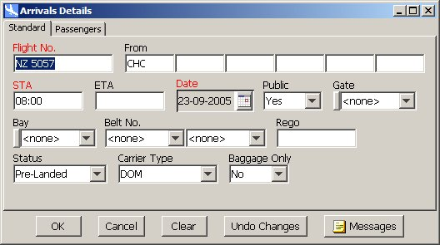

In details windows such as this, fields that have a red label are “required” fields. Required fields must have a non-blank value for the flight to be valid.

The “Related Flight” field is special in that its value is sensitive to the value of the Bay field. At any time the Related Flight field will only allow selection of a flight from the “other” table (in this case, Departures) that is either on the same bay, or not currently allocated to a bay.
By filling in the Related Flight field, the user is effectively “linking” two flights together on the Bay Allocator Window.

The Messages button may be used to display a list of any messages that have been associated with the flight being edited.

Departures Window
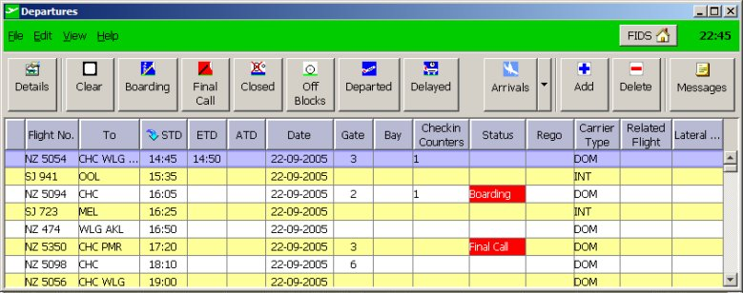
This window is a primary window for use by regular Operators of the FIDS. In this window, the Operator will be able to see an up-to-date picture of the current flights that are scheduled to depart the airport.

Each line in the table of data represents a single record in the database. These records are generated from the departure timetable. One off or charter flights that are not in the timetable can be added to the database using this screen. If the new flight is to be a regular event then it should be entered in the timetable accessed from the “Time Tables" menu on the FIDS Home Window.

Updated information such as estimated time of departure (ETD), off blocks, gate, etc can be added to the flight by entering the details window.

Check in counter details are entered in the “Check Ins" window.

A flight’s details can be edited by double clicking on the record, clicking on the Details button or using the edit menu.

The colour of a line or status field reflects the corresponding flights status. This “status" is also displayed in the Status column. The status can be quickly changed by using the appropriate speed button.

Departures Speed Buttons

Invokes the details window for the selected flight.

Clears the status of the flight.

Changes the status of the selected record to "Boarding"

Changes the status of the selected record to "Final Call"

Changes the status of the selected record to "Closed"

Changes the status of the selected record to "Off Blocks"

Changes the status of the selected record to "Departed" and records the actual time of departure in the ATD field.

Changes the status of the selected record to "Delayed"

Takes the operator to the arrivals window.

Takes the operator to the checkin window.

Adds a new record to the table. Note that this button’s action is also available from the “Edit" menu.

Deletes the selected record from the database. Note that this button’s action is also available from the “Edit" menu.

Invokes the messages window for the selected flight.

Departures Details Window
This window is used to allow the user to change the details of a departing flight.

Flights are created in the system from one of the following sources:
- FIDS Timetable
- Airline Feed
- External System Feed (e.g. AODB)
- Manual User Entry

Whatever the source of the flight, the flight will be created with specific details that are used to identify and describe that flight.

A flight may always be edited, providing the user has the required authorisation. To edit a flight the user would invoke the “Details” window for the flight by either double clicking on the flight, or by selecting the flight and clicking on the “Details” speed button.

This will invoke a details window similar to the one below. The field selection will differ depending on authorisation level.

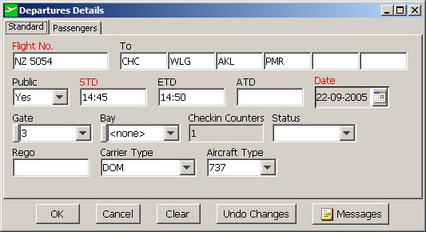

In details windows such as this, fields that have a red label are “required” fields. Required fields must have a non-blank value for the flight to be valid.

The “Related Flight” field is special in that its value is sensitive to the value of the Bay field. At any time the Related Flight field will only allow selection of a flight from the “other” table (in this case, Arrivals) that is either on the same bay, or not currently allocated to a bay.

By filling in the Related Flight field, the user is effectively “linking” two flights together on the Bay Allocator Window.

The Messages button may be used to display a list of any messages that have been associated with the flight being edited.

Checkins Window

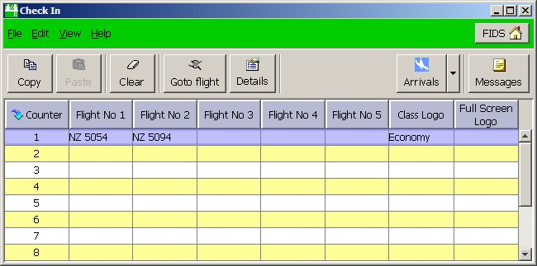

This window allows users to assign flights to check in counters. Up to five flights can be assigned to one checkin counter.

To assign a flight to a check in counter, double click on the record (or click on Details) to invoke the details window. Enter the flight numbers to be assigned to the checkin.

A code may also be assigned in the Airline Logo field which may be used to override the logo normally displayed for an airline. The Airline field may also be used when no flights are entered to allow a logo-only checkin screen to be displayed.

The Class Logo field may be used to assign an economy, business or first class logo to the checkin counter screen. If the airline has its own special class logo it will be linked in the system configuration to the airline and class logo so that the correct logo is displayed automatically. When all details are entered select “OK"

If you want to assign the same flight/s to a number of checkins, select each of the checkin counters that you want to change, and then click on the details button. Any changes made in the details window will then be applied to all of the selected checkin counters.

Checkins Speed Buttons

Copies the selected checkin counter (only one may be selected) to the clipboard.

Pastes a copied checkin counter from the clipboard into the selected checkin counter(s).

Clears any selected checkin counters so that no flights are allocated.

Invokes the Departures window, and selects the first flight allocated to the selected checkin counter.

Invokes the details window for the selected checkin counter.

Takes the operator to the arrivals window.

Takes the operator to the departures window.

IATA Code Window
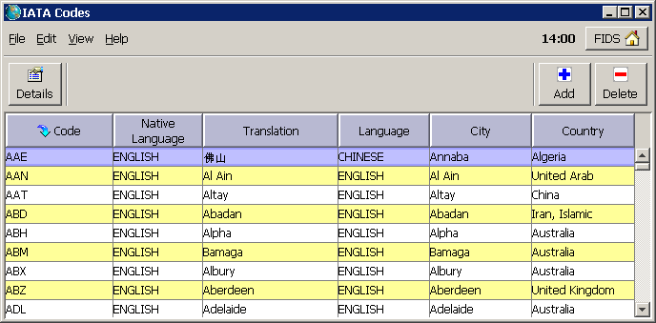
The FIDS maintains a large table of IATA codes. For each IATA code in the database, it is possible to record the current and forecast minimum and maximum temperatures. If the system is configured appropriately, then this information may be displayed where appropriate throughout the airport.

The IATA Code window allows operators to enter temperature information for any IATA codes in the system.

Only the System Manager is able to add, remove or edit records in this table.

The and buttons are used to add and remove records in the table. They will only be visible to the System Manager.

IATA Code Speed Buttons

Invokes the details window for the selected IATA Code.

Adds a new record to the table. Note that this button’s action is also available from the “Edit" menu and is only available to System Managers.

Deletes the selected record from the database. Note that this button’s action is also available from the “Edit" menu and is only available to System Managers.

IATA Code Details Window
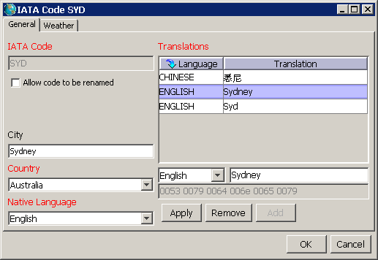
The IATA Code Details window brings together each IATA code in the database with all current translations for that IATA code. The actual translations are stored in the Translations table, but this details window allows the System Manager to add new translations for an IATA code, or to change other relevant details about the IATA Code being edited.

Note, that unless the user explicitly checks the "Allow code to be renamed" checkbox, an IATA code can not be renamed. In normal circumstances this is not something that would be needed.

The native language of an IATA code is used in multilingual display systems to let the display system know which language is required by the IATA code when it is displayed. For example, if a flight to Beijing is being displayed, the native language would be "Chinese". As a result, the flight details would be displayed in both English and Chinese (where appropriately configured).

Timetable Editor Window

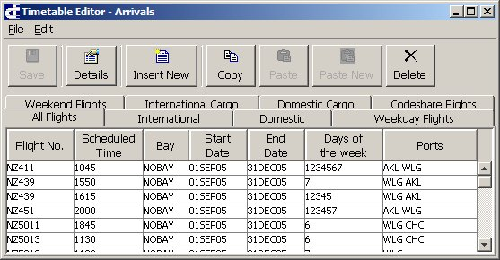

This window is used to view and edit the timetables from which the system bases its flight information. There are separate timetable files for the arriving and departing flights.

Using the tabs, it is possible to change the selection of flights that are shown. By default, the “All Flights” tab will be selected.

An entry in this window represents a flight that is scheduled to appear in the system on a specific set of days in the week between two dates. Each time the system creates a flight from the timetable, the flight is populated using the values in the timetable entry.

New flights may be added to the timetable by clicking on the “Insert New” speed button.

Timetable Editor Speed Buttons

Invokes the details window for the selected flight.

Invokes a blank flight details window so that a new flight may be added to the timetable.

Copies the selected flight to the clipboard.

Pastes a copied flight from the clipboard into the selected flight.

Creates a new flight in the timetable using the details from the copied flight in the clipboard.

Deletes the selected flight from the timetable.

Timetable Editor Details Window

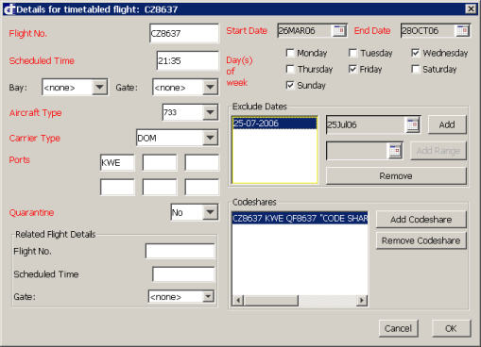

This window is displayed whenever a timetable flight entry is double-clicked or the “Details” button is clicked. It may also be invoked when the “Insert New” button is clicked.

It allows the user to enter details into a specific flight. Fields that have a red label are required, and, if blank will prevent the user from accepting the details.

A flight will be generated by the system for each day that is ticked between the specified dates. The only exception to this is when specific dates are excluded.

Dates and Date ranges may be excluded by entering a date next to the “Add” and "Add Range" buttons and clicking on the appropriate button. The number of dates/ranges that may be excluded is limited to 20 by the FIDS. If it is necessary to setup a timetabled flight with a large number of dates that are excluded, it is possible to enter two separate timetable entries for the same flight, but with different date ranges.

A flight may also be associated with one or more codeshare flights. To add a codeshare flight, click on “Add Codeshare”. To remove a codeshare, click on the codeshare to be deleted and click on “Remove Codeshare”. To edit the details of a codeshare, double-click on the codeshare.
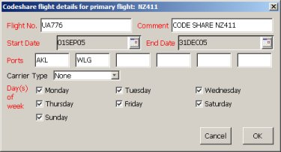
For a codeshare to be associated with a flight, it must operate within the same date range, and operate on some, if not all, of the same days.

A timetable flight may be specified as having a “Related Flight”. Such a flight is created in the “other” table; if the timetable record is for an arrival, the related flight is a departure, and vice versa.

A Related Flight must have a valid scheduled time, and can’t be entered unless the Bay field has been filled in.

A flight in the timetable can be allocated a bay number that it will be allocated to when it is created. This is done by filling in the “Bay” field.

The Gate field, whilst required may validly have a blank value. When a flight is created from the timetable that has a bay, but no gate specified, the gate field is obtained from the Bay to Gate Mapping

Likewise if a related flight is created by the FIDS and it’s gate field is blank, then the gate field is obtained from the Bay to Gate Mapping.

Crawling Lines Window

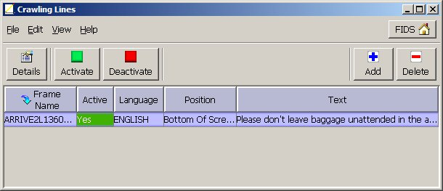

This window allows the Operator to create and edit crawling lines for any of the public or staff displays. A crawling line is a line of text that scrolls (or crawls) from across the screen. This feature may be used to place special notices on specific screens throughout the airport.

A crawling line record consists of five key fields:

Frame Name: The frame name is a unique name that defines what information is on a given screen. By specifying a frame name in a crawling line, the Operator effectively places the crawling line on all screens that are displaying that frame.

Active: If this field is “Yes" then the crawling line is active and on display. A value of “No" deactivates the crawling line.

Position: This field allows the operator to specify where on the screen the crawling line should appear. Note that some frames do not support all positions.

Foreground: This is the foreground colour for the text of the crawling line.

Background: This is the background colour for the text of the crawling line.

Text: This is the actual text that will crawl across the screen.

To edit a crawling line double click on the record, then click on “Details” or select details from the Edit menu.

Crawling Lines Speed Buttons

Activates all crawling lines that are selected.

Deactivates all crawling lines that are selected.

Adds a new crawling line record to the database.

Deletes the selected crawling line from the database.

Reports Window

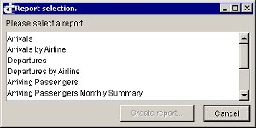

This window allows the user to select and generate a report from historical data. The report generated will be displayed in a browser such as Internet Explorer. The report can be viewed and printed from within the browser using the browsers features

In order to generate a report, double-click on the desired report, or click on “Create Report”. The following window will then be displayed, allowing you to enter parameters that may be used to define which flights are to be included in the report.

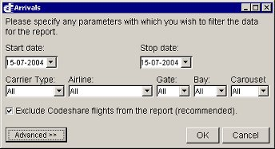

Screen Selector Window

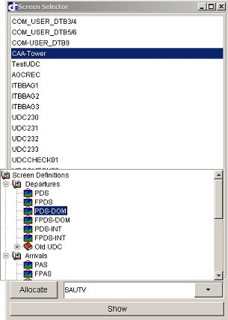

This window, which is only available to System Managers, hides off to the right of the screen and is “popped up" by moving the mouse to the right hand side of the display. The purpose of this screen is to make temporary changes to which screen a UDC is displaying.

The window has a list of each Universal Display Controller (UDC) in the systems configuration. Selecting the UDC will in the control box at the bottom of the window display which screen is currently displayed by the UDC. By then clicking on the arrow a selection tree will be revealed. This allows any screen that the system is capable of displaying to be assigned to the selected UDC. The selection of a new screen can be made by double clicking or single clicking followed by clicking the “Allocate" button.

The “Show" button will request that the selected UDC send back a static image of what it is displaying. This is a useful fault finding tool. If the display is blank and the “Show" brings up the expected image, then the monitor or it’s cabling is at fault.

Bay Allocator Window
Using the Bay Allocation window, it is possible to see, at a glance, how busy each bay is. This allows airport staff to see, ahead of time, which bays are becoming congested and to take action.

The FIDS GUI can be used to pair up arriving and departing flights on the same bay for the same airline; therefore, preventing the display from becoming cluttered. The flight-pairs are displayed in a time-line, or Gantt chart display, as shown in the figure below:

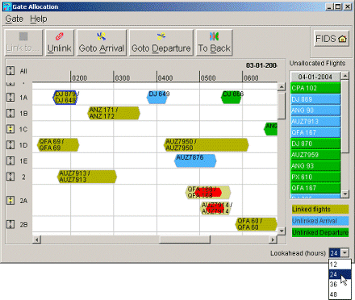
Note that this system is not designed to perform automatic gate optimisation, but it does simplify the process of bay management and bay allocation for airports.

To link two flights simply select one of the two flights to be linked, and click on the “Link to” speed button.

This will result in the bay being highlighted, and a blue line originating at the selected flight that follows the mouse. By then clicking on one of the highlighted flights in the same bay, a link will then be created between the two flights.
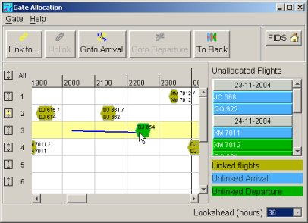
Another way to manipulate flights on the Gantt chart is to right-click on the flight. This will invoke a pop-up menu that provides the same functions as the speed buttons.

By simply selecting a flight-pair with the mouse, you may:
- move the flight pair to another bay by simply dragging it with the mouse
- display the flight details of either Arrivals or Departures
- manually unlink the flight pair, in case they are mistakenly paired up
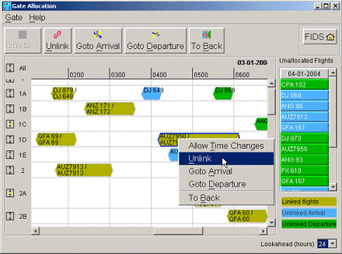
When flights are in conflict for a bay, they are shown with a red centre. In such situations, they can be shown overlapping each other (which saves space on the screen), or next to each other (which is often easier to read). See the following figure demonstrating this feature.
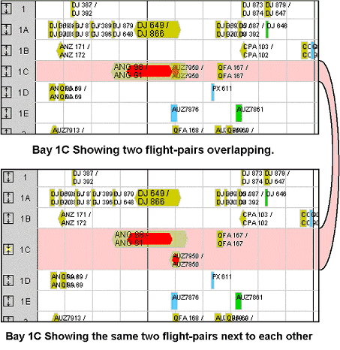
To change the way conflicting flights are shown click on the bay’s Zoom button ().

Flights may also be linked from the Arrivals or Departures details windows. Linking flights requires that a flight’s “Related Flight” field be filled in.

In order to simplify the use of the Bay Allocator Window, flights that are created from the FIDS Timetable may be configured such that they are pre-allocated to a specific bay. It is also possible to configure a pair of flights to be pre-linked when they are created from the timetable. For more information about this please refer to Timetable Editor Window.

Bay Allocator Speed Buttons

Allows the operator to link the selected flight in the Gantt chart to another flight from same airline on the same bay. After clicking on this, a blue line from the selected flight will follow the mouse within the bay until the user clicks on a valid flight within the same bay. At that point the two flights will be linked.

This button allows the user to unlink a linked pair of flights.

Will invoke the arrivals window and select the arrival flight that was selected on the Gantt chart.

Will invoke the departures window and select the departure flight that was selected on the Gantt chart.

Will push the selected flight behind any other flights on the bay.

Translations Window
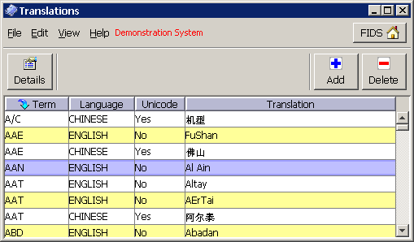
All static text that is displayed on the FIDS screens is obtained from an online dictionary called the Translations table. This window allows the system manager to maintain the Translations table.

The reason that the dictionary is called a Translations table is that it may contain translations of a term in one of several languages. For example, if the FIDS is configured to display flight information on the public screens in English and Chinese, the Translations table will contain translations for things such as IATA codes, and column headings in both English and Chinese.
When the FIDS displays one flight route information on a public screen, it will find the longest translation for the IATA code in the translations table in the appropriate language.

This window allows Operators to look up destination codes to determine their full description. On staff displays, only the code is displayed, whereas on all public displays the full description is displayed.

Only the System Manager is able to edit records in this table, or add and remove them.

